1. [SELECT](http://localhost:8080/phpmyadmin/url.php?url=https://dev.mysql.com/doc/refman/8.0/en/select.html" \t "mysql_doc) \* FROM `obat` ORDER BY pembuat\_obat DESC;

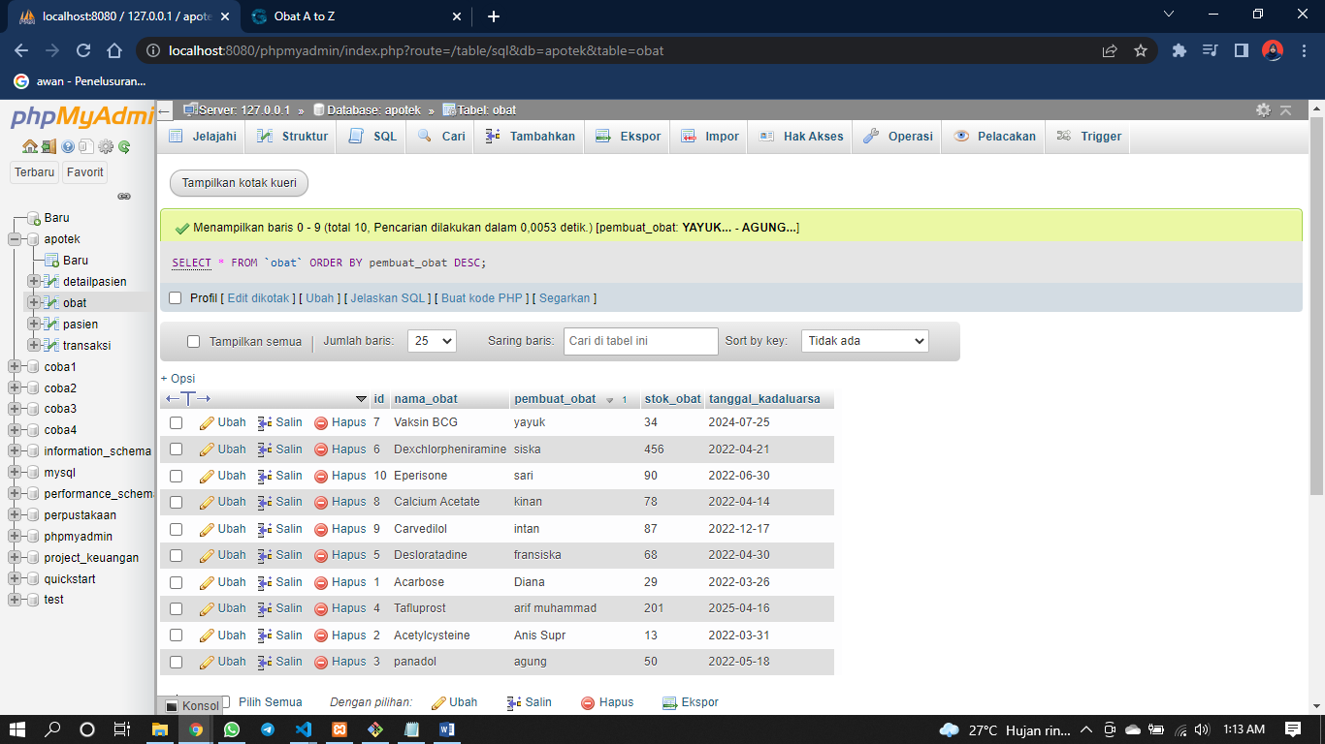

1. [SELECT](http://localhost:8080/phpmyadmin/url.php?url=https://dev.mysql.com/doc/refman/8.0/en/select.html) \* FROM `obat` ORDER BY stok\_obat ASC;

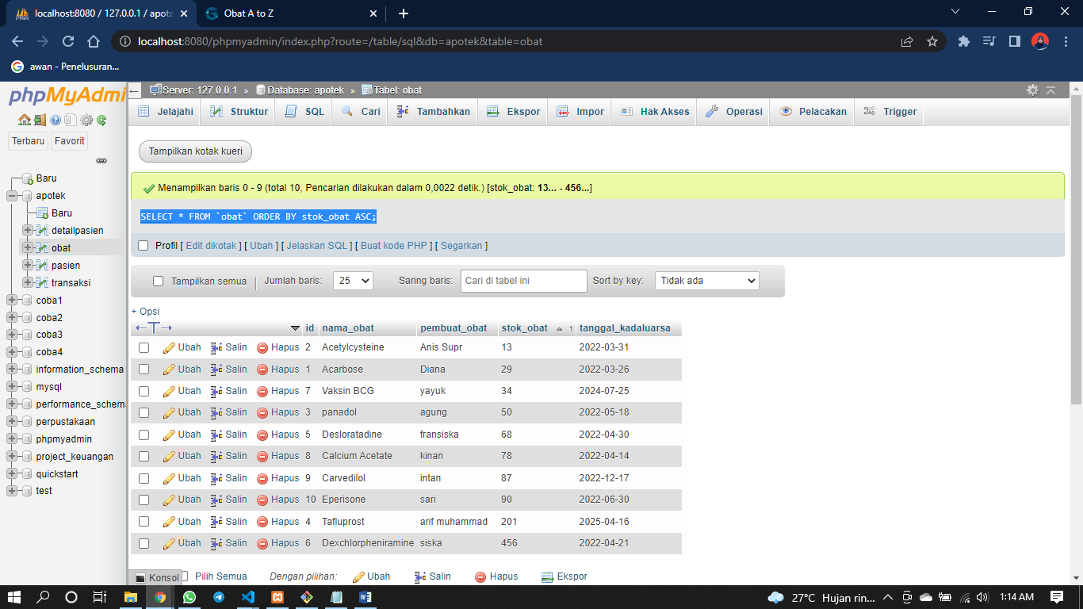

1. [SELECT](http://localhost:8080/phpmyadmin/url.php?url=https://dev.mysql.com/doc/refman/8.0/en/select.html) \* FROM `obat` WHERE nama\_obat [LIKE](http://localhost:8080/phpmyadmin/url.php?url=https://dev.mysql.com/doc/refman/8.0/en/string-comparison-functions.html#operator_like) '%calcium%';

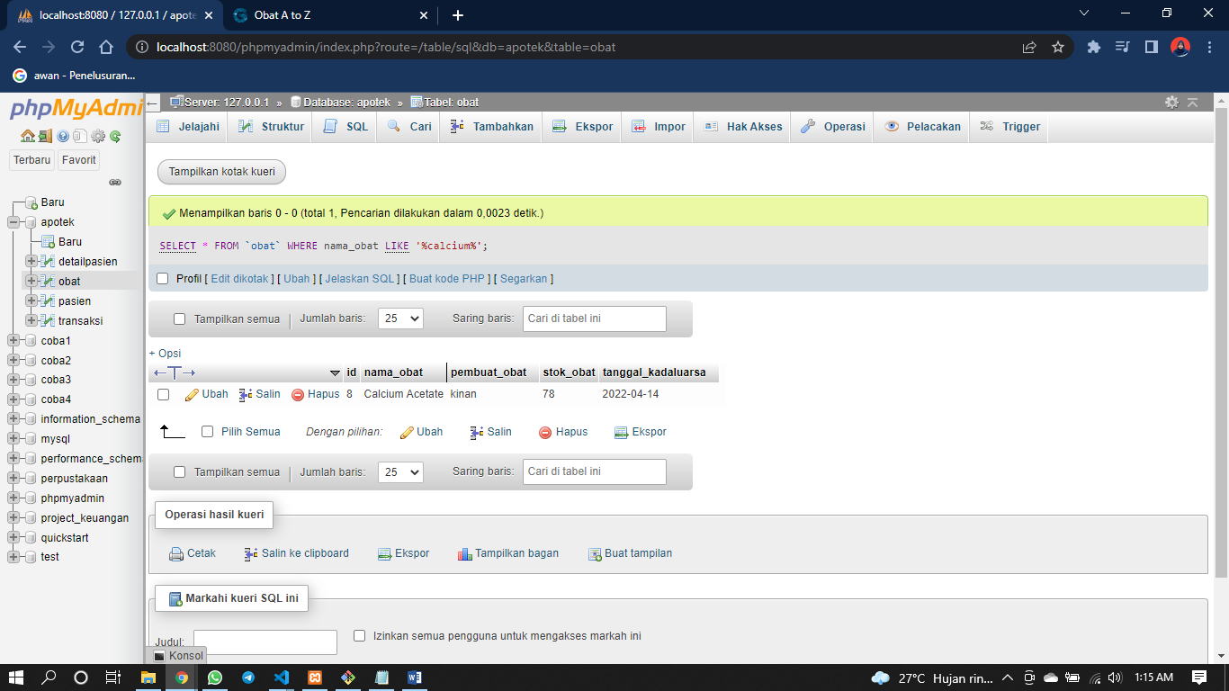

1. [SELECT](http://localhost:8080/phpmyadmin/url.php?url=https://dev.mysql.com/doc/refman/8.0/en/select.html) \* FROM `obat` WHERE pembuat\_obat [LIKE](http://localhost:8080/phpmyadmin/url.php?url=https://dev.mysql.com/doc/refman/8.0/en/string-comparison-functions.html#operator_like) '%intan%';

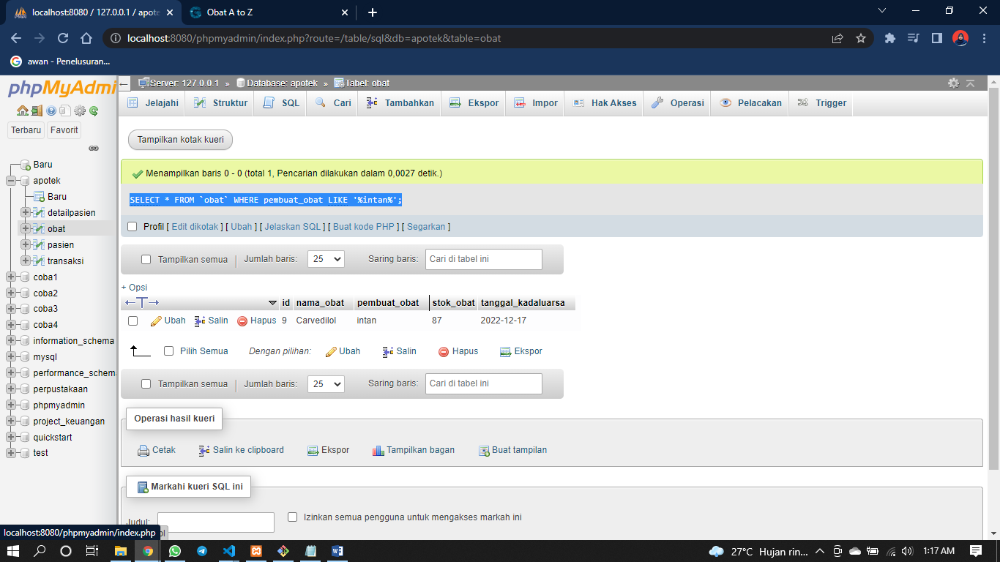

1. [SELECT](http://localhost:8080/phpmyadmin/url.php?url=https://dev.mysql.com/doc/refman/8.0/en/select.html) nama\_obat, [SUM](http://localhost:8080/phpmyadmin/url.php?url=https://dev.mysql.com/doc/refman/8.0/en/group-by-functions.html#function_sum)(stok\_obat) as total FROM `obat` GROUP BY nama\_obat;

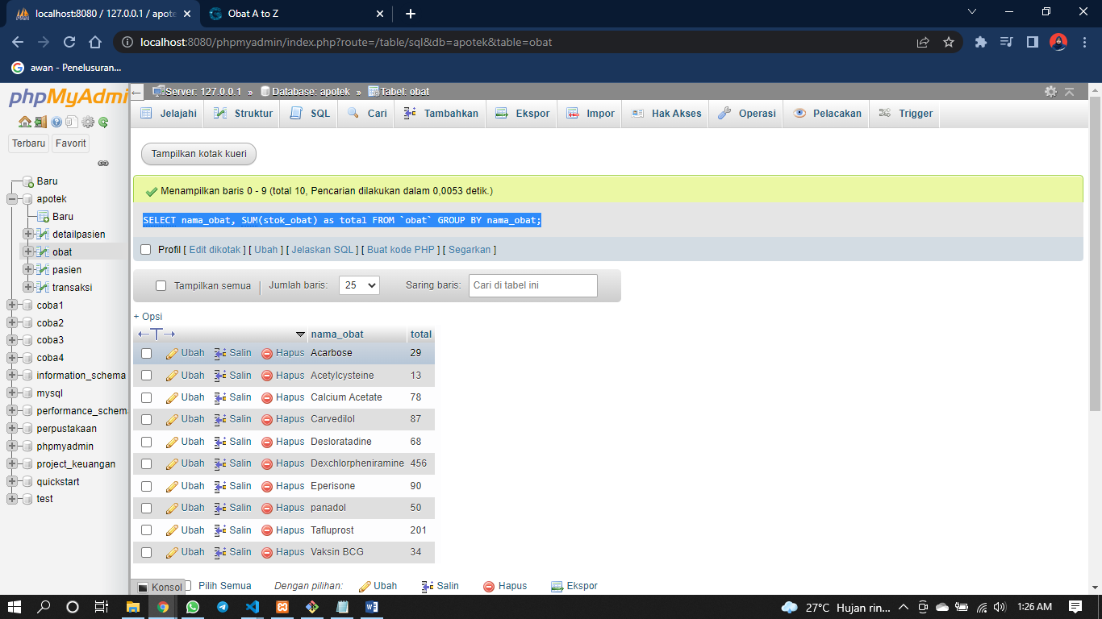

1. [SELECT](http://localhost:8080/phpmyadmin/url.php?url=https://dev.mysql.com/doc/refman/8.0/en/select.html) \* FROM `obat` ORDER BY nama\_obat DESC;

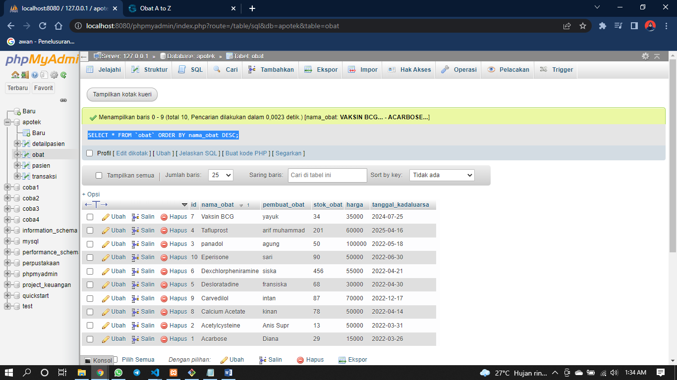

1. [SELECT](http://localhost:8080/phpmyadmin/url.php?url=https://dev.mysql.com/doc/refman/8.0/en/select.html) \* FROM `obat` ORDER BY nama\_obat ASC;

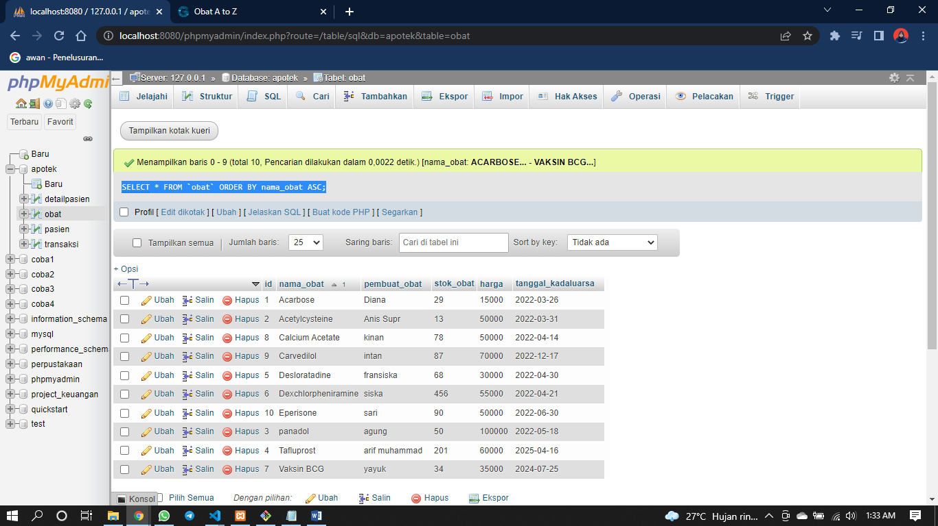

1. [SELECT](http://localhost:8080/phpmyadmin/url.php?url=https://dev.mysql.com/doc/refman/8.0/en/select.html) nama\_obat, [SUM](http://localhost:8080/phpmyadmin/url.php?url=https://dev.mysql.com/doc/refman/8.0/en/group-by-functions.html#function_sum)(stok\_obat\*harga) as total FROM `obat` GROUP BY nama\_obat;

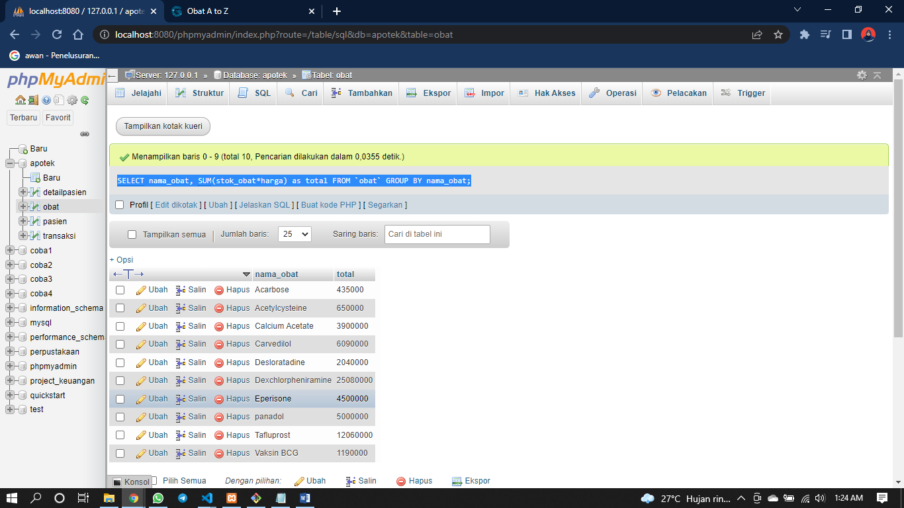

1. [SELECT](http://localhost:8080/phpmyadmin/url.php?url=https://dev.mysql.com/doc/refman/8.0/en/select.html) nama\_obat, [SUM](http://localhost:8080/phpmyadmin/url.php?url=https://dev.mysql.com/doc/refman/8.0/en/group-by-functions.html#function_sum)(stok\_obat\*harga) as total FROM `obat` WHERE harga >= 50000 GROUP BY nama\_obat ORDER BY nama\_obat DESC;

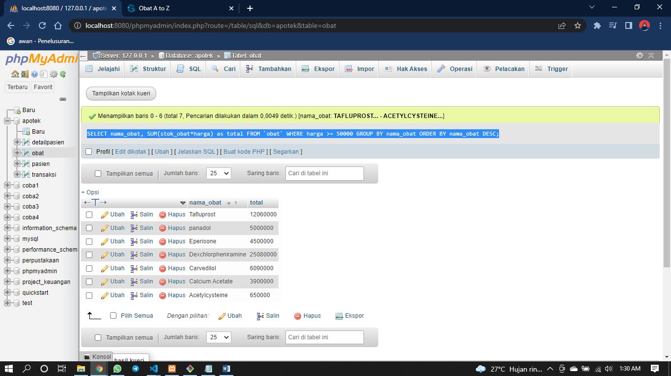

1. [SELECT](http://localhost:8080/phpmyadmin/url.php?url=https://dev.mysql.com/doc/refman/8.0/en/select.html) nama\_obat, [SUM](http://localhost:8080/phpmyadmin/url.php?url=https://dev.mysql.com/doc/refman/8.0/en/group-by-functions.html#function_sum)(stok\_obat\*harga) as total FROM `obat` GROUP BY nama\_obat ORDER BY nama\_obat ASC;

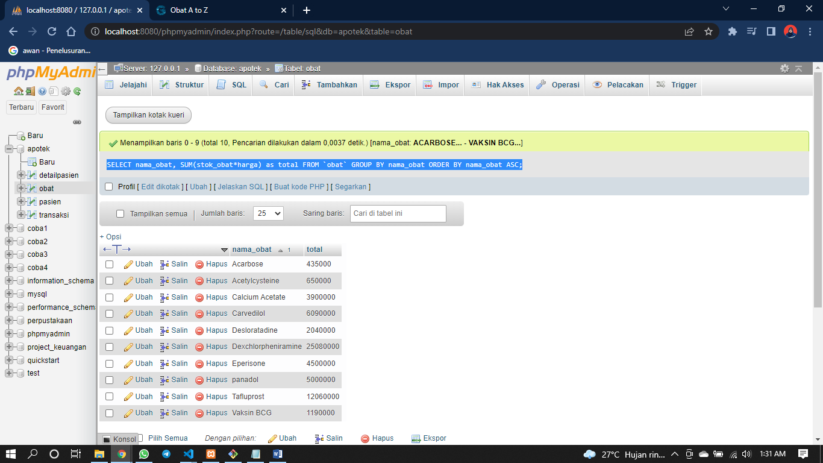

1. [SELECT](http://localhost:8080/phpmyadmin/url.php?url=https://dev.mysql.com/doc/refman/8.0/en/select.html) nama\_obat, [SUM](http://localhost:8080/phpmyadmin/url.php?url=https://dev.mysql.com/doc/refman/8.0/en/group-by-functions.html#function_sum)(stok\_obat\*harga) as total FROM `obat` GROUP BY nama\_obat ORDER BY nama\_obat DESC;

